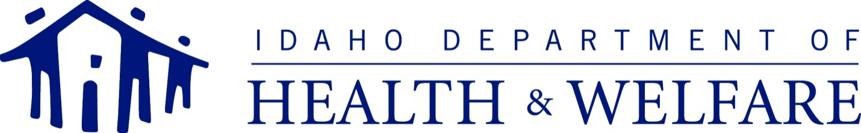
C.L. “BUTCH” OTTER – Governor  RUSSELL S. BARRON – Director |  | Matt Wimmer - Administrator  DIVISION OF MEDICAID  Post Office Box 83720  Boise, Idaho 83720-0009  PHONE: (208) 334-5747  FAX: (208) 364-1811
September 1, 2017

To the Members of Community NOW!,

This letter is an update on Medicaid’s response to the Community NOW! Service and Support Recommendations Report (Community NOW! Report) dated July 18, 2017. Community NOW! submitted the report to the Department of Health and Welfare, Division of Medicaid. Members of Community NOW! gave a presentation of the report to the Director of the Idaho Department of Health and Welfare, Russ Barron, Deputy Director of the Idaho Department of Health and Welfare Lisa Hettinger, and other stakeholders, Medicaid administrators, managers and staff on August 18, 2017. Three preliminary meetings have been set throughout the month of September for Medicaid staff to discuss the Community NOW! Report. At these meetings, we will begin looking at what changes might be possible, and begin discussing how Medicaid might be able to prioritize potential changes. The following individuals are anticipated to attend these preliminary meetings:

Matt Wimmer (me), Medicaid Administrator
Elizabeth Kriete, Deputy Administrator
Art Evans, Bureau Chief
Michael Case, Program Manger
Karen Westbrook, Alternative Care Coordinator
Venecia Andersen, Project Manager
Charina Newell, Deputy Attorney General, Idaho Attorney General’s Office
Cynthia Yee-Wallace, Deputy Attorney General, Idaho Attorney General’s Office

Following these meetings, Medicaid would like to hold a meeting with the members of Community NOW! to get feedback about Medicaid’s initial discussions. We will let you know when this meeting with Community NOW! members is scheduled. We will also keep you updated as Medicaid moves develops a more formal response to the Community NOW! Report.

If you have questions or comments, please feel free to contact Medicaid directly by calling 1-844-793-1286 or emailing KW@dhw.idaho.gov. Thank you again to the members of Community NOW! and to everyone who provided time and input for this important process and development of this report.

Matt Wimmer
Administrator
Idaho Department of Health and Welfare, Division of Medicaid

